btree, brin, hash

scripts - V17__Create.sql, V17.1__Insert.sql, V17.2__Create_Index.sql, btree.sql, hash.sql. brin.sql

index structures sizes:  
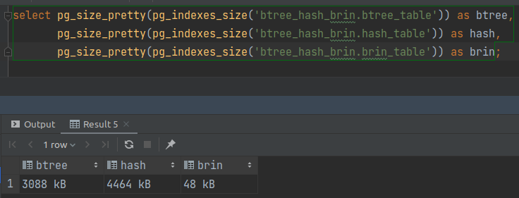

benchmarks:  
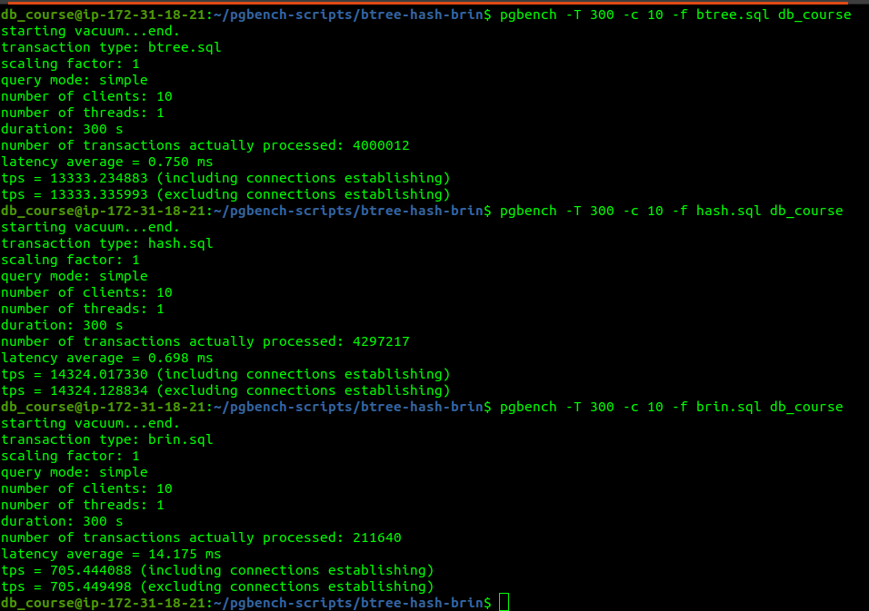

btree_table: latency = 0.750 ms tps = 13333.335993

hash_table: latency = 0.698 ms tps = 14324.128834

brin_table: latency = 14.175 ms tps = 705.449498